1. Get more variety of features
   1. EMA – Exponential moving average (decaying in time).
   2. RSI, Stochastic K, MACD, CCI, ATR, Accumulation/Distribution
2. Past volatilities, where volatility can be: (a) square root of naive sample variance

(b) result of EWMA as applied to variance

(c) drift-independent volatility computed with the method from Yang & Zhang (2000) that takes into account an overnight jump in price

1. Consider different time windows (periods), eg, 1 day, 5 days, 10, days, 21 days, and 50 days if

suitable. It is best to work with non-overlapping window but that imposes significant historical data requirement.

- Logistic, including penalised regression, Naive Bayes

- Support Vector Machines

- Decision Trees (Regression version) and Ensemble Methods (AdaBoost)

What is the limitation of the k-fold crossvalidation?

<https://www.learndatasci.com/tutorials/python-finance-part-3-moving-average-trading-strategy/>

A good article on EMA

# Using Pandas to calculate a 20-days span EMA. adjust=False specifies that we are interested in the recursive calculation mode.

ema_short = data.ewm(span=20, adjust=False).mean()

Another moving average:

<https://towardsdatascience.com/implementing-moving-averages-in-python-1ad28e636f9d>

<https://github.com/voice32/stock_market_indicators/blob/master/indicators.py>

<https://medium.com/@maksutov.rn/thinking-of-predicting-stock-market-prices-im-here-to-help-with-my-indicators-library-for-python-60e9d5ba1509>

<https://towardsdatascience.com/technical-analysis-library-to-financial-datasets-with-pandas-python-4b2b390d3543>

RSI - Explanation

<http://www.andrewshamlet.net/2017/06/10/python-tutorial-rsi/>

RSI - Code

<https://stackoverflow.com/questions/20526414/relative-strength-index-in-python-pandas>

MACD – Code and explanation

<https://towardsdatascience.com/implementing-macd-in-python-cc9b2280126a>

1] RSI RSI measures the magnitude of recently gain to recently loss in an trial to determine overbought and oversold conditions of an asset

1] MACD MACD presents the difference between a fast and slow exponential moving average (EMA) for closing prices. Fast is a short-period average, and slow is a long period one

<https://journals.plos.org/plosone/article/file?id=10.1371/journal.pone.0209922&type=printable>

Good explanation of MACD – No need of signal just the code is good enough.

<https://www.researchgate.net/publication/316848946_An_Artificial_Neural_Network-based_Stock_Trading_System_Using_Technical_Analysis_and_Big_Data_Framework>

EWMA-STD

<https://pandas.pydata.org/pandas-docs/version/0.17.0/generated/pandas.ewmstd.html>

<https://stackoverflow.com/questions/55588157/what-is-the-numpy-equivalent-of-pandas-ewm-std>

Yang Zhang – drift independent

<https://github.com/jasonstrimpel/volatility-trading/blob/master/volatility/models/YangZhang.py>

Good Course to cover in future

<https://www.udemy.com/volatility-trading-analysis-with-python/>

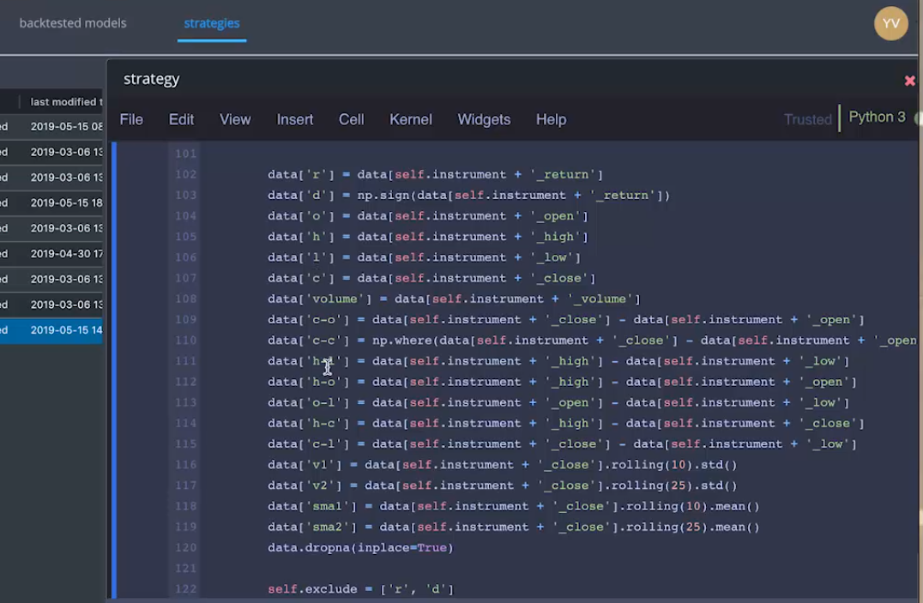

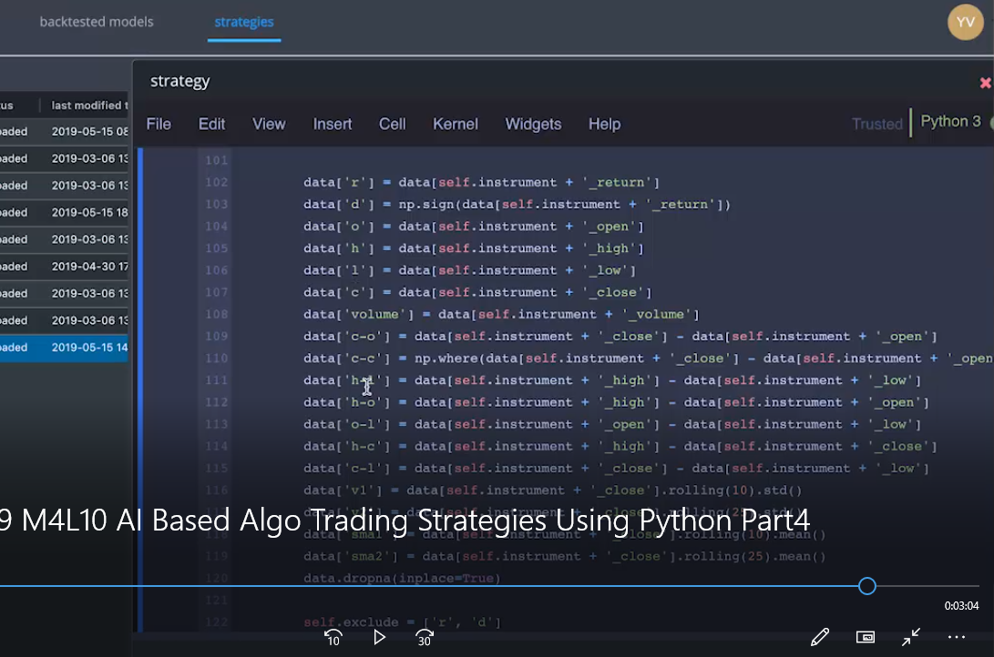

Standard Deviation is the squared root of Variance. Standard Deviation is a measure that is used to quantify the amount of variation or dispersion of a set of data values.

<https://mubaris.com/posts/statistics/>